**Assignment 4**

*// 1. Write a program to calculate the sum of following series where n is input by user.*

*// e.g 1 + 1/2 + 1/3 + 1/4 + 1/5 +…………1/n*

import java.util.Scanner;

public class SeriesSum {

    public static *void* main(*String*[] args) {

*Scanner* I=*new* Scanner(System.in);

        System.out.print("Enter the number you want to sum upto-:");

*int* n=I.nextInt();

*double* sum=0;

*for* (*int* i = 1; i <= n; i++) {

    sum+=(1/i);

}

I.close();

System.out.println("Sum is-:"+sum);

    }

}

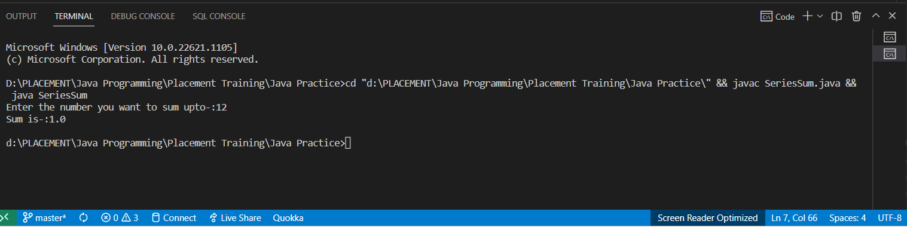

*// 2. Find out Prime Number*

public class PrimeOptimized {

    public static *void* main(*String*[] args) {

*int* num=128;

*if*(num==1)

        {

            System.out.println("PRIME");

*return*;

        }

*if*(num==2 || num==3){

            System.out.println("PRIME");

*return*;

        }

*if*(num%2==0 || num%3==0){

            System.out.println("NOT PRIME");

*return*;

        }

*for*(*int* i=5;i*i<=num;i+=6){

*if*(num%i==0 || num%(i+2)==0){

    System.out.println("PRIME");

*return*;

}

}

System.out.println("PRIME");

    }

}

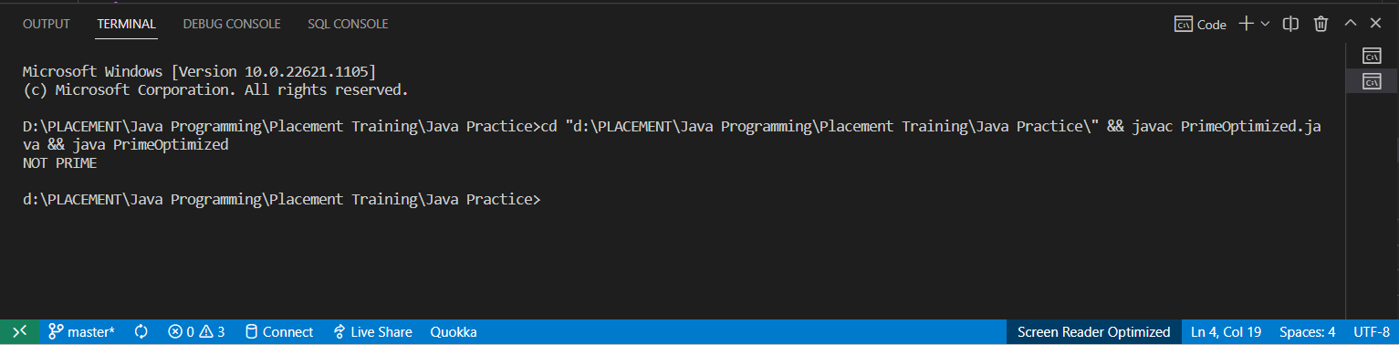

*// 3.  Reverse a Number (Hint : % , *)*

public class Reverse{

    public static *void* main(*String*[] args) {

*int* num=1234;

*int* sum=0;

*while*(num!=0){

          sum=(sum*10)+(num%10);

          num/=10;

        }

        System.out.println(sum);

    }

}

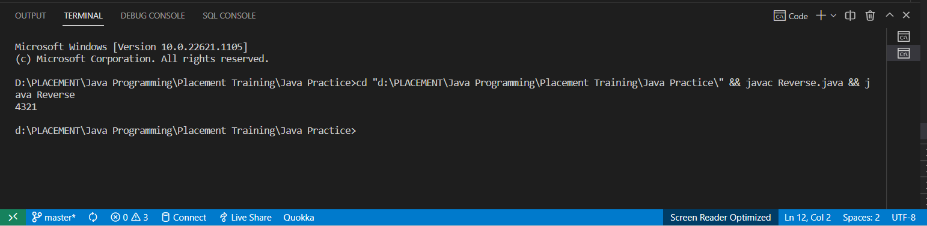

*// 4.LCM of a Number*

public class Lcm {

   public static *void* main(*String*[] args) {

*int* a=20,b=40;

*int* gcd=0;

*// Finding the greatest common divisor or HCF*

*while*(a%b!=0){

                 gcd=a%b;

                 a=b;

                 b=gcd;

            }

*// LCM*GCD=a*b*

            System.out.println("Lcm is-:"+(a*b)/gcd);

   }

}

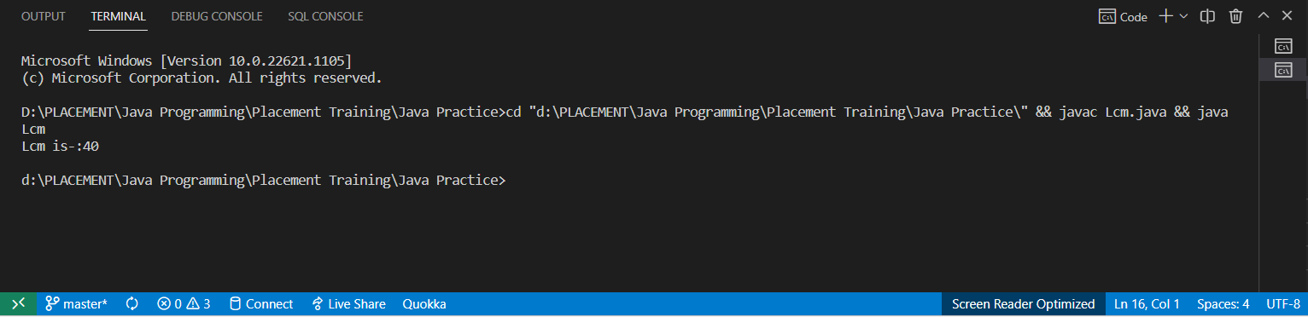

*// 5. Implement a program to find out whether a number is divisible by the sum of its digits.*

*// Display appropriate messages.*

*// e.g 2250 - Yes*

*// e.g 123 - NO*

public class SumDigitDiv {

 public static *void* main(*String*[] args) {

*int* num=202;

*int* dub=num;

*int* sum=0;

*while*(dub!=0){

     sum+=(dub%10);

     dub/=10;

    }

*if*(num%sum==0)

    System.out.println("Its Divisible");

*else*

    System.out.println("Not Divisible");

 }

}

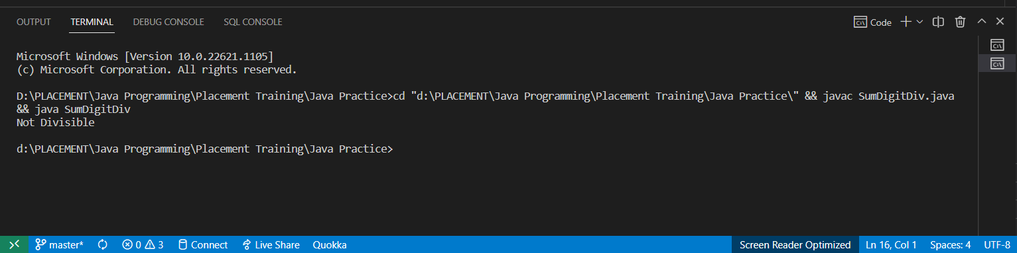

*// 6. Implement a program to find out whether a number is a seed of another number.*

*// A number X is said to be a seed of number Y if multiplying X by its every digit equates to Y.*

*// E.g.: 123 is a seed of 738 as 123*1*2*3 = 738*

*// e.g 123, 738 - Yes*

*// e.g 45,1000 - No*

import java.util.Scanner;

public class SeedNumber {

 public static *void* main(*String*[] args) {

*Scanner* I=*new* Scanner(System.in);

    System.out.print("Enter the first number-:");

*int* x=I.nextInt();

    System.out.print("\nEnter the second number-:");

*int* y=I.nextInt();

*int* dub=x;

*// int checker=x;*

*while*(dub!=0){

        x*=(dub%10);

        dub/=10;

    }

*if*(x==y)

    System.out.println("Its a seed Number");

*else*

    System.out.println("Not a seed Number");

I.close();

 }

}

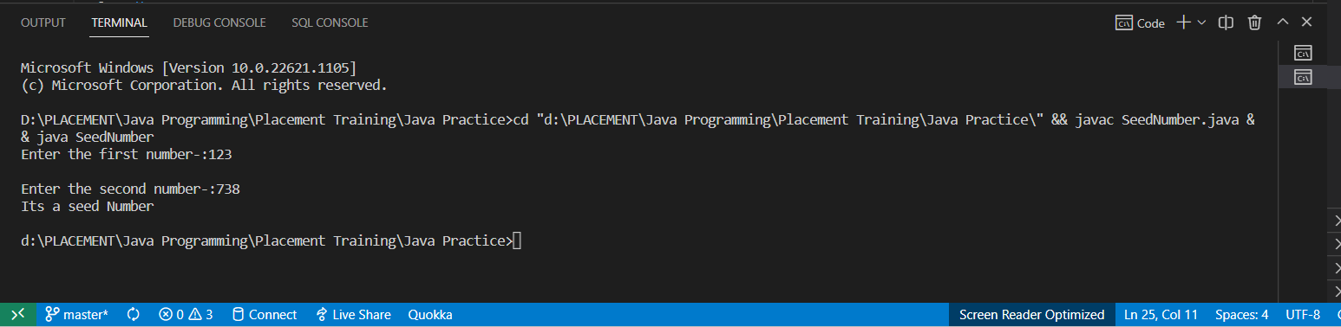

*// 7. ArmStrong Number e.g 153 1 ^3 + 5 ^ 3 + 3 ^3 = 153*

public class ArmstrongNumber {

    public static *void* main(*String*[] args) {

*int* num=153;

*int* dub=num;

*int* rep=num;

*int* count=0;

*int* sum=0;

*while*(dub!=0){

            count++;

            dub/=10;

        }

*while*(num!=0)

        {

            sum+=Math.pow(num%10, count);

            num/=10;

        }

*if*(sum==rep)

        System.out.println("Armstrong Number");

*else*

        System.out.println("Not a Armstrong Number");

    }

}

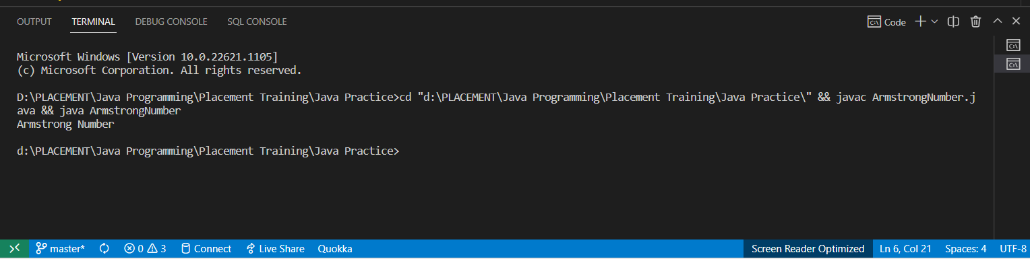

*// 8. WAP to find the Prime Number b/w 1 to N*

import java.util.*\**;

public class PrimeRange {

    public static *void* main(*String*[] args) {

*Scanner* I=*new* Scanner(System.in);

        System.out.println("Enter the starting number");

*int* a=I.nextInt();

        System.out.println("Enter the ending number");

*int* b=I.nextInt();

*for* (*int* i = a; i <=b; i++) {

*int* count=0;

*for* (*int* j = 1; j <=i; j++) {

*if*(i%j==0)

                count++;

            }

*if*(count==2)

            System.out.println(i);

        }

        I.close();

    }

}

